# Module 3**(Testing on Live Application)**

1.What is RDBMS?

* RDBMS stands for Relational Database Management System. RDBMS is the basis for SQL, and for all modern database systems like MS SQL Server, IBM DB2, Oracle, MySQL, and Microsoft Access.

A Relational database management system (RDBMS) is a database management system (DBMS) that is based on the relational model as introduced by E. F. Cod.

2.What is SQL?

* SQL is a language of database, it includes database creation, deletion, fetching rows and modifying rows etc. SQL is an ANSI (American National Standards Institute) standard but there are many different versions of the SQL language. SQL is the standard programming language of relational DBs SQL is a standard computer language for accessing and manipulating databases. SQL is a great example of a declarative programming language.

3.Write SQL Commands.

⚫ DDL – Data Definition Language

⚫ DML – Data Manipulation Language

⚫ DCL – Data Control Language

⚫ DQL – Data Query Language

4.What is join?

* A join is an SQL operation performed to establish a connection between two or more database tables based on matching columns, thereby creating a relationship between the tables. Most complex queries in an SQL database management system involve join commands.

5.Write type of joins.

⚫ INNER JOIN: returns rows when there is a match in both tables.

⚫ LEFT JOIN: returns all rows from the left table, even if there are no matches in the right table.

⚫ RIGHT JOIN: returns all rows from the right table, even if there are no matches in the left table.

⚫ FULL JOIN: returns rows when there is a match in one of the tables.

6.How Many constraint and describes it self.

* SQL constraints are used to specify rules for the data in a table.
* Constraints are used to limit the type of data that can go into a table. This ensures the accuracy and reliability of the data in the table. If there is any violation between the constraint and the data action, the action is aborted.
* Constraints can be column level or table level. Column level constraints apply to a column, and table level constraints apply to the whole table.
* NOT NULL - Ensures that a column cannot have a NULL value
* UNIQUE - Ensures that all values in a column are different
* PRIMERY KEY - A combination of a NOT NULL and UNIQUE. Uniquely identifies each row in a table
* FORIGEN KEY - Prevents actions that would destroy links between tables

7.Difference between RDBMS and DBMS.

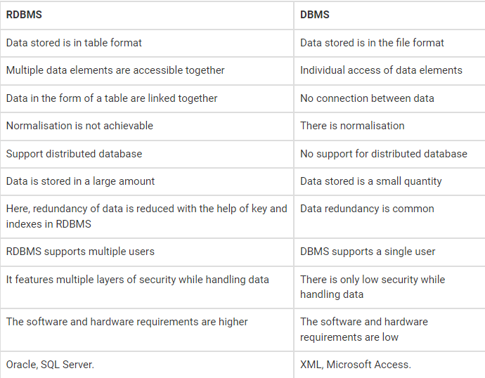

8.What is API Testing?

* Application Programming Interface is a software interface that allows two applications to interact with each other without any user intervention another definition , API is a computing interface which enables communication and data exchange between two separate software systems. The purpose of API Testing is to check the functionality, reliability, performance, and security of the programming interfaces. In API Testing, instead of using standard user inputs and outputs, you use software to send calls to the API, get output, and note down the system’s response. API tests are very different from GUI Tests and won’t concentrate on the look and feel of an application.

9.Types of API Testing.

* There are mainly 3 types of API Testing

⚫ Open APIs: These types of APIs are publicly available to use like OAuth APIs from Google. It has also not given any restriction to use them. So, they are also known as Public APIs.

⚫ Partner APIs: Specific rights or licenses to access this type of API because they are not available to the public.

⚫ Internal APIs: Internal or private. These APIs are developed by companies to use in their internal systems. It helps you to enhance the productivity of your teams

10.What is Responsive Testing?

* A responsive web design involves creating a flexible web page that is accessible from any device, starting from a mobile phone to a tablet. Furthermore, a responsive web design improves users’ browsing experience. Considering this from a quality assurance perspective, a responsive web design requires thorough evaluation using a variety of devices before it is ready to go live. Software testers may find it challenging to perform responsive design testing as a variety of factors are to be looked into during the testing phase. Some points to be understand for Responsive Testing. The challenges involved in testing a responsive website How website testing differs from a mobile device to a computer Rules and guidelines to be followed during responsive design testing and Lastly, various tools available to perform responsive testing.

11.Which types of tools are available for Responsive Testing?

* LT Browser
* Lembda Testing
* Google Resizer
* I am responsive
* Pixel tuner

12.What is the full form of .ipa, .apk?

* Apk- android application package
* Ipa- ios application

13.How to create step for to open the developer option mode ON?

